Like our Hillcrest PTO Facebook Page
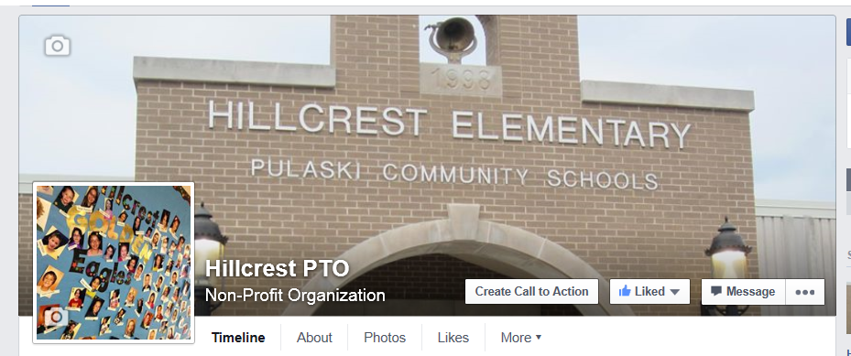
Receive Updates, Events and Fun Facts
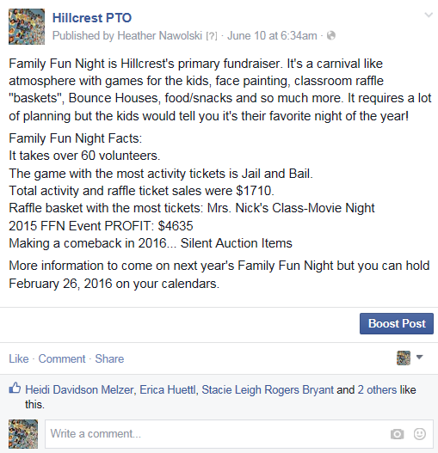
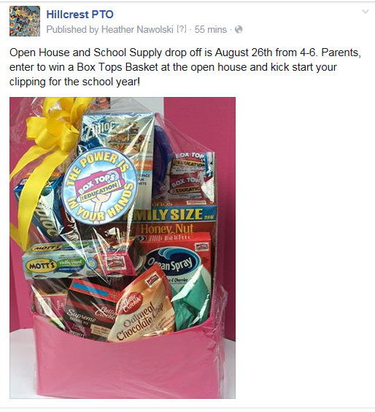

Can’t find us? There are several Hillcrest PTO’s in this world! Ours is: https://www.facebook.com/pages/Hillcrest-PTO/444659162380034 or email Heather Nawolski at es1gt@yahoo.com for a direct link.

