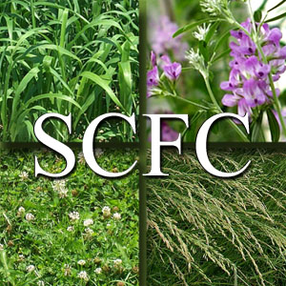

2013 Scholarship Application Form

The Shawano County Forage Council is an organization of producers and agribusiness members with the mission of promoting profitable forage production. As part of this goal, the Shawano County Forage Council strives to promote agricultural education for the students of Shawano County by awarding annual scholarships to be used for a university, technical college, or short course program.

Criteria for Selection: The applicant must:
- Be a Shawano County resident.
- Be pursuing an agriculture-related degree at a university or technical college, with a preference given to applicants studying crops or forages.
- Provide evidence of educational achievement.
- Demonstrate a record of active participation in extracurricular activities.

Scholarships: There are three scholarships available.
- $500 for a student continuing a four year degree program
- $250 for a student beginning a four year degree program
- $250 for a student beginning or continuing at a technical college or short course program

Application Process: The following items must be received in the Shawano County UW-Extension Office by May 15, 2013:
- Completed scholarship application form
- Copy of most recent transcripts (does not need to be an official copy)
- One letter of recommendation
- Mail to Shawano County UW-Extension at 311 N Main St #101, Shawano, WI 54166, email to rhonda.sumnicht@co.shawano.wi.us or fax to (715) 526-4875
- Scholarship winners will be notified by the end of May and funds will be distributed after evidence is provided of a successful completion of the fall semester.

Name: Birthdate / /

Parents’ Names:

Home Address:

County of Permanent Residence: Phone:

E-Mail Address:

Education:

High School Name: GPA:________ of

Class Rank: of Date of Graduation: _

University/Technical College:

Intended Major:

Status for Fall 2013:  Freshman  Sophomore  Junior Senior Other

Career Goals: Briefly describe your plans for the future including education and career goals. Share some of the experiences that have encouraged you to enter into an agricultural field.

Extracurricular Activities: List your participation in extracurricular activities and indicate any leadership positions held in the organizations, including church, school, FFA, 4-H, etc. Include Name of organization, year, office, duties.

Work Experience: Describe your work experiences which might relate to your academic major or your college goals.

You may attach one additional page if necessary.

