Applying for a NWTC Scholarship
- Go to www.nwtc.edu
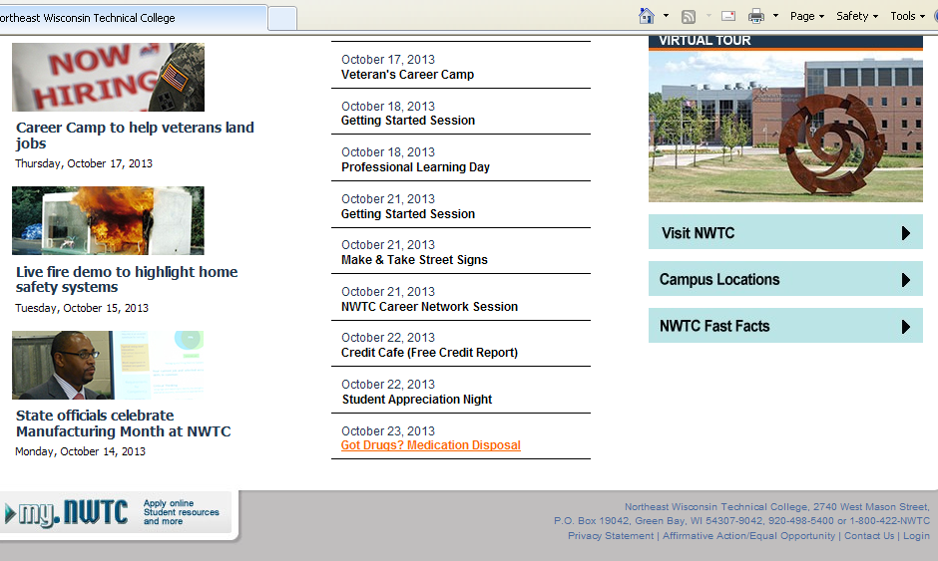
  - Click on the MY.NWTC student portal on the lower left hand side of any page

- Log in with your User ID (student ID) and password (self-created)
- If you DO NOT have a User ID or my.NWTC account, please click on the “Create/Activate My Account” button. Complete the information required to get a User ID instantly. On return visits then log in as noted originally.
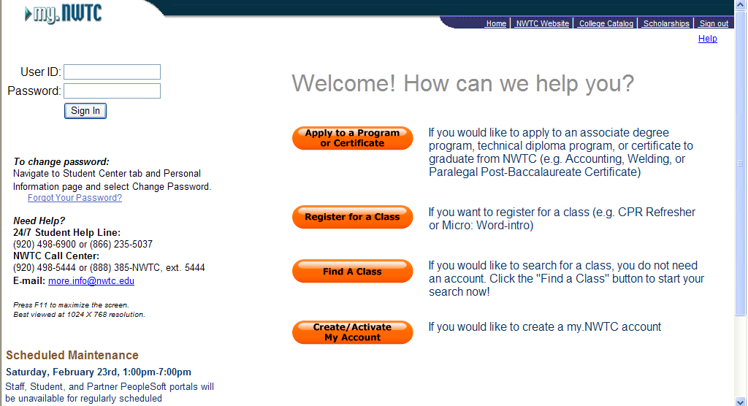

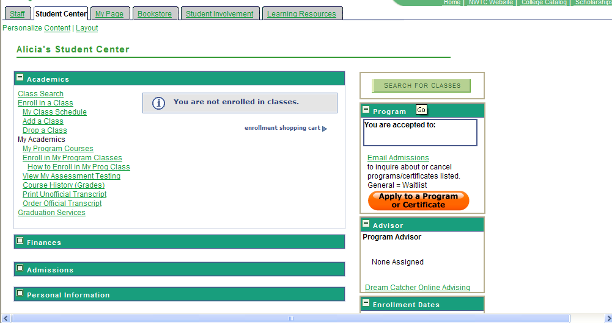
- Click on the “Finances” header

- Click on the “Apply for a Scholarship” link under “Scholarships” header
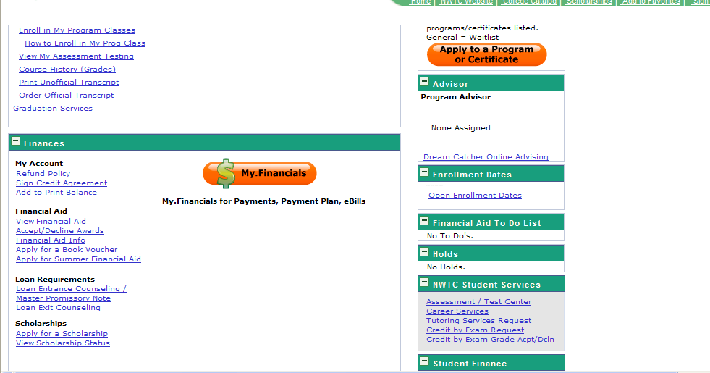

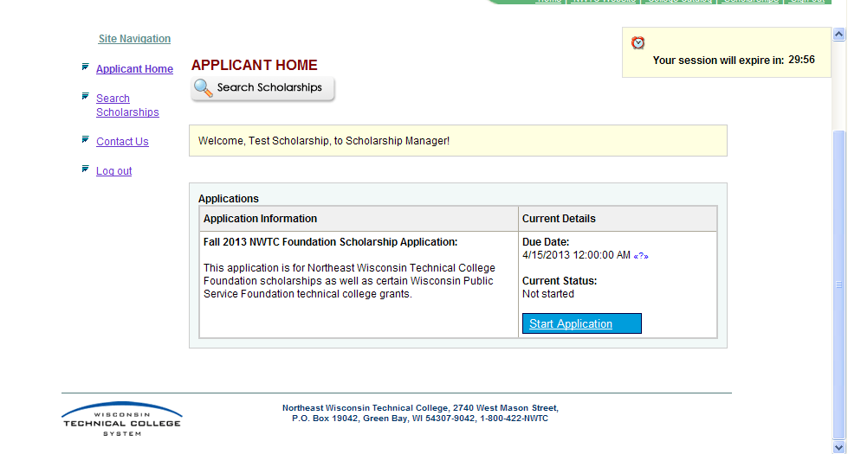
- From here you can start your application by clicking on the “Start Application” box and answering the questions as completely as possible.

